DOOR ENTRY DIRECT LTD

SMART.NET-IP PC BASED DOOR ACCESS CONTROL
DESKTOP – WEB – MOBILE

PLANNING & InstallatioN Guide: ISSUE 2023/1

Door Control Unit Installation 4
Planning 4
Power Supply 4
Cable & Wiring Choices 4
End of Line Termination 5
Door Monitor Contact Input 5
Alarm Relay Output 5
Exit Request Input 6
Door Reader Connections 6
Important Door Control Unit Installation Checklist 7
Testing a DCU Door Control Unit Installation Locally 7
Door Control Unit Serial Address 8
Door Control Unit Wiring Diagram 9
USB-485-ISO-TB Boxed Isolated Network Adapter Interface 10
Power Source 10
Connections 10
Interface Commissioning 10
LAN-IP-485-TB Boxed Isolated Network Adapter Interface 11
Power Source 11
Connections 11
Status LED’s 12
Removable PCB Links 12
Adapter IP Addressing 12
Firewall Considerations 13
LAN-IP Device Installer Utility 13
Advanced LAN Setup 14
LAN Adapter Serial Settings 14
Installing System Doors in Remote Locations 15
Router & Port Forwarding Considerations 15
Multiple Adapters at Remote Locations 15
WebAdmin Server & Remote Management 16
Working Over the Internet 16
Starting the WebAdmin Server at Boot Time 16
USB Desktop Enrolment Reader 17
Installing 17
Testing 17
Secure Login 17
Access Control System Schematics 18
USB-485 Adapter Networking 19
USB-485 + LAN-IP-485 Adapter Networking 19
Access Control Software 20
Download the WebAdmin Edition Software 20
Installing the Software 20
Launching the Software 20
Web Administration Console Login 21
Help Resource 21

The following manual details information relating to the correct planning and installation of this door access control system. They replicate and collate instructions that may also be provided with other related electronic devices or sub-systems you have purchased. Details on how to configure and manage your software installation are provided through help pages reachable from the Web Administration Console software directly. It is recommended, if you are planning an installation for the first time, to seek guidance or further training from your supplier.

Door Control Unit Installation
Best results will be achieved when following these instructions as they describe the planning and installation of a single Access Control Door or Entrance. A wiring diagram with notes is shown below, that states clearly all the common associated devices that may be required for each single door installation. The main circuit board can be removed during enclosure installation but must be stored and handled with care.

Planning
The DCU Single Door Control Unit is designed to be installed locally to the door or entrance it will serve in a dry internal location. This allows all cable connections to be short and efficiently run. All connections are made by removable side-entry polarised screw terminals designed for multi-stranded cable types. All cables entering the door control unit housing must not be coiled up inside but routed efficiently through the various edge and rear cable entry knockouts and drill points of the enclosure. Cable tidy anchor points are provided with suitable cable ties provided. Please ensure that the rear enclosure mounting screws do not foul the PCB or terminals.

Power Supply
The DCU can be powered from a single low voltage DC regulated supply only. The voltage input range must be between 12-16 Volts DC; ratings outside of these may cause damage to the control unit and / or its associated devices. The DCU single door control unit has been designed for low power operation. Its quiescent current is only 80mAmp rising to 300mAmp with both proximity readers connected and the lock and alarm relays energised.
Always use an individual power supply to power each door and its associated local components in isolation. Never share the power supply between adjacent door control unit as ground loops may be created that can cause communication bus faults over the RS485 interconnecting network. The current capacity of the PSU should be greater than the locking peak current consumption by at least 300mAmp (0.3A)

Cable & Wiring Choices
The correct choice of cable types will affect the overall performance and cost of the system installation so care and understanding of the types and when to use them is important.
Never use of CAT5/6 or similar cable as its solid core construction breaks easily under mild mechanical stress and will make service & fault finding difficult. Always use the correct stated cable types, detailed below

The differing types of cable and when to use them are explained in the table below:
Application | Cable Type | Max Distance | Notes
Communication | BELDEN 8132  BELDEN 9842 | 1200 M  1200 M | Use Belden equivalents if required. The screen is connected to communications terminal ‘G’ from Adapter to the door control units
Readers | BELDEN 9535  6 CORE SECURITY | 50 M  20 M | Connect the screen to ‘0V’ reader input terminal
Power & Lock | 4-6 CORE SECURITY | 20 M | Any suitable unscreened low voltage multi-stranded cable can be used with sufficient conductor cross sectional area for the current drawn
Egress & Contact | 4-6 CORE SECURITY | 20M | Any suitable unscreened low voltage multi-stranded cable can be used with sufficient conductor cross sectional area for the current drawn

The total networking communication length must not exceed 1.2KM (1200M) from a single USB-485 or LAN-IP-485 Adapter and must not contain any spurs or star points. You can connect a total of 128 Door Control Units on one continuous network cable installation from one USB-485 or across multiple LAN-IP-485 Adapters (segments).

End of Line Termination
In the last door control unit, which is the one furthest away from the USB-485 or LAN-IP-485 interface connection segment you must employ end-of-line resistor termination. Connect the two 120-Ohm resistors provided with the USB-485 or LAN-IP-485 Adapters, one across the last door control unit terminals T+ & T- and the other across R+ & R-. To check that the termination is correct, disconnect the USB-485 or LAN-IP-485 interface from the computer or network switch and measure with a multi-meter set on the resistance range that you can read between 60 to 70 ohms across the T pair and again across the R pair. The exact readings will depend on the total networking cable length and its resistance.

Door Monitor Contact Input
The Door Monitor Contact input is used to monitor the physical state of the door in its frame or closed position. This is normally achieved with a standard intruder alarm magnetic contact set. The type required is single pole normally closed when the door is closed. The Door Monitor Contact will only monitor the physical state of the door and not the locked or security status of the lock. The Door Monitor Contact will activate the Alarm Relay Output (relay 2) when one of the following two conditions are met. If the doors lock mechanism is defeated and the door is opened by force, or if the door is opened through a valid access, but then did not close correctly or fully afterwards. The timing or delay of these events is programmable through the Web Administration Console software.

Alarm Relay Output
The Alarm Relay Output (relay 2) can be used locally to the door or entrance to indicate if the door or entrance is in the alarm state. An alarm state condition is generated when the door monitor contact is fitted, and the door is forced open or left open too long. Any general-purpose sounder or other device may be switched with a rating not greater that 24VDC at 2A. The relay has normally open and closed volt free contact set (form C). If the magnetic door contact is not fitted to any door control unit, then this condition is automatically detected and disabled (no need to link it out on the screw terminals).

Exit Request Input
The Exit Request Input is normally used if a button is required to exit through the controlled door or entrance. It can be reassigned on the software to be used as a general-purpose input for other purposes if required. Configurable options available are, intruder alarm set detect, power supply fault detect, general tamper input detect and all-doors release (free access) with a single closing contact. By default (factory) the operation is as an Exit Request Button utilised with a push-to-make momentary switch. If the exit button function input is later reassigned by the software application all functions are normally open with a closing circuit for an active state. If the release (free access) all system doors function is required, only a single connection at one door control unit is required as the host computer running the software, will manage the command for the rest of the system. Never apply a voltage of any kind to this input as damage to the control electronics may occur.

Door Reader Connections
Reader connections are generally of a short distance and so you may use standard intruder alarm connection cable if this is the case. Please review the above cable choices table for exact types, depending on distance to the appropriate reader input on the door control unit. Below are the wiring colours for the standard reader types you may encounter:
Reader Model | Type | Connections | Notes
UPR (DOOR ENTRY DIRECT) | 125KHZ Universal Proximity Reader | RED = 12V  BLACK = 0V  GREEN = D0  WHITE = D1  BLUE = GLED | Use screened Belden 9535 over 10M
MPROX | 125KHZ ASK 26 Bit Wiegand | RED = 12V  BLACK = 0V  GREEN = D0  WHITE = D1  BLUE = GLED * | Use screened Belden 9535 over 10M  * Blue wire not present / required with MPROX-ECO variant
MPROX - MF | 13.56MHZ Smart Card Reader (CSN) | RED = 12V  BLACK = 0V  GREEN = D0  WHITE = D1  YELLOW = GLED | Use screened Belden 9535 over 10M
MPROX – MF - KP | 13.56MHZ Smart Card Reader (CSN) c/w PIN Keypad | RED = 12V  BLACK = 0V  GREEN = D0  WHITE = D1  YELLOW = GLED | Use screened Belden 9535 over 10M
HID READERS | 125KHZ WIEGAND FAMILY | RED = 12V  BLACK = 0V  GREEN = D0  WHITE = D1  ORANGE = GLED | Use screened Belden 9535 over 10M

Important Door Control Unit Installation Checklist
For the overall success and long reliable operation of the installation, it is important to observe certain installation rules for each door. The following checklist is designed to ensure qualified installers have adhered to all important installation criterion:
- POWER SUPPLY: each door control unit is powered from a local single DC power supply with the correct current capacity rating for all local devices, including any electronic locks.
- POWER SUPPLY: the DC input voltage measured at the T6 screw terminals is between 12 to 16VDC.
- POWER SUPPLY: with the mains power isolated from the power supply, check there is no resistance or continuity between the 0V (-) DC output and the single-phase mains earth input or metal case chassis.
- POWER SUPPLY: if you are using fail-safe locks that require DC power to remain locked, then ensure your power supply is a battery backed type, and a suitable rechargeable battery is fitted.
- LOCAL CABLING: all advised cabling types are being used and are not Category 5 or similar single stranded types.
- RS485 DATA CABLING: must be Beldon 8132 or Beldon 9842 and never Category 5 or similar single stranded types.
- ELECTRONIC LOCKING: if any form of inductive electronic locking device is being used, ensure that the supplied diode has been fitted and fitted correctly. The supplied diode (1N4001) is polarity conscience and must be installed at or in the electronic locking device.
- PUSH TO EXIT BUTTON: if installed ensure that this device is a push-to-make momentary type.
- MAGNETIC DOOR CONTACT: if installed ensure this device is a single pole normally closed when the door is closed type.
- DOOR PROXIMITY READERS: ensure the correct advised cable types have been used and any reader powered LED is illuminated. You may also check that the correct DV voltage is present at any reader.
- CLOCK MEMORY CELL: ensure that the 3V lithium button cell provided is installed carefully and in the correct orientation, in the receptor on the door control unit PCB.

Testing a DCU Door Control Unit Installation Locally
Most of each individual door control unit installation can be tested in isolation to confirm correct installation before connecting to a network of other system doors and the host computer. This is strongly recommended, as it will ensure a smooth flow to the next stage of networking the doors and connecting to the host computer.
The Lock, Exit Button, Magnetic Door Contact, Relay 1, Relay 2 and both Proximity Door Readers if fitted, can be simply checked for correct operation.
1) To test that the Door Lock (relay 1) is operating correctly briefly press the Request to Exit Button. The Door Lock should unlock for approximately 5 seconds and then relock.
2) To test the Door Lock (relay 1) and the Alarm Output (relay 2) briefly press the Request to Exit Button and then open the door thus opening the Magnetic Door Contact. The Door Lock should relock within about 5 seconds. After 20 seconds, if the door is still open (ajar) then the Alarm Output Relay 2 will operate until the door is closed and secure.
3) To test for Door Forced Open you will need to disable the door locking mechanism and without pressing the Request to Exit Button, open the door which in turn opens the Magnetic Door Contact. The Alarm Output Relay 2 will operate until the door is closed and secured once again.
Other readers are available, but their feedback signals may differ. The DCU control unit is fitted with two industry standard 26 Bit Wiegand interfaces so many third-party readers types including bio-metrics may be used
4) To test each Proximity Reader, present a card or tag at each unit installed. The reader should beep and flash green briefly to indicate the reader has read the presented compatible card or tag. After about 2 seconds the door control unit will flash the red light to green 6 times quickly, to indicate that this token has been read and processed but is unknown to the Door Control Unit (access denied).
It is not possible to test or check the correct operation of the RS485 network at this stage

Door Control Unit Serial Address
It is recommended at this stage, that the 6-digit unique serial number located on a white label is documented along with a descriptive name for the door control unit location. The serial number provides the unique address required to find it on the multi-drop RS485 network and network segment, so a note of the segment in which it resides is also important. This information will be required when the software is installed on the host computer and door records are to be defined and addressed correctly.

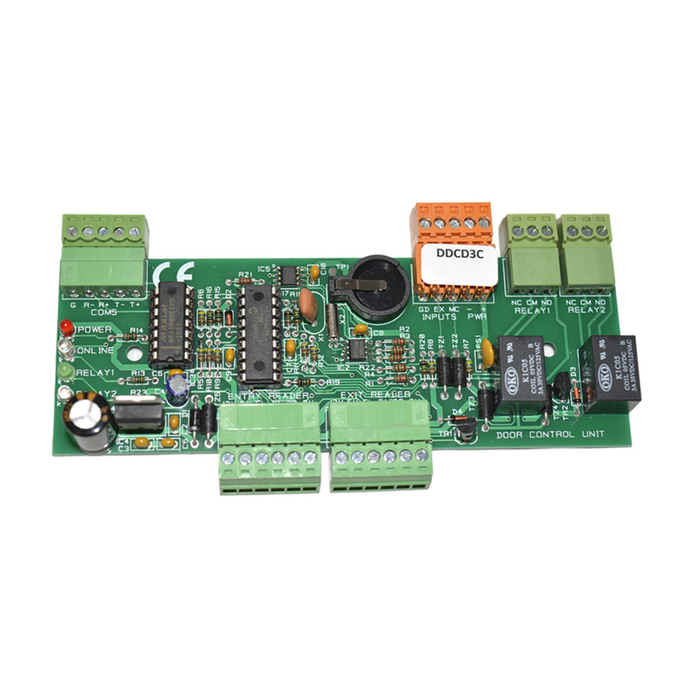

Door Control Unit Wiring Diagram

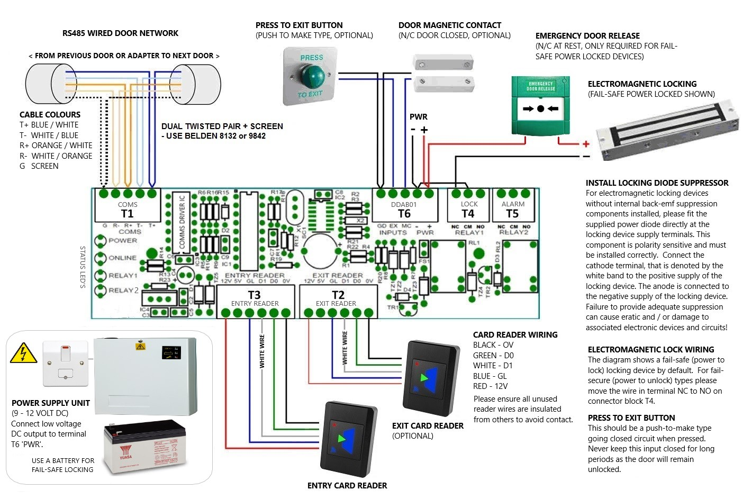

USB-485-ISO-TB Boxed Isolated Network Adapter Interface
Best results will be achieved when following these instructions as they describe the installation and best practice for this adapter product. The USB-485-ISO-TB Adapter has been designed to simplify the connection of a multi-drop network of Door Control Units. You can use this product to connect the host computer to up-to 128 Door Control Units from a single USB connection. This adapter variant has been improved to achieve galvanic isolation between the control computer and the access control network. This promotes improved multi-drop RS485 networking performance and the reduction in possible ground loop communication errors.

Power Source
The USB-485-ISO-TB Adapter derives its power source from the standard USB port it is connected. It does not require any additional power sources. This interface consists of two parts, the USB connector cable with 6 coloured terminations and the interface printed circuit board. You will need to first terminate the USB connector cable ends, to the interface printed circuit board at the fixed 6-way USB cable terminal connections. The main RS485 door access control communication network is terminated at the removable 5-way connector end. A small housing is provided with cable strain reliefs to enclose the terminations.

Connections
The access control network connection will allow the network connection of up to 128 door control units with a single continuous multi-drop cable installation. The connections from the door network output to the first control unit and onward to the next are shown below:
Network Adapter First Control Unit Next Control Unit…
T+ T+ T+
T- T- T-
R+ R+ R+
R- R- R-
G (Screen) G (Screen) G (Screen)
Two LEDs are embedded in the USB cable connector body. When at least one door is defined, and the system software is actively communication with the door(s) then the red LED indicates a transmission to the door control unit(s) and the green LED a reply. With these LED’s and the online LED in each door control unit, any network cabling errors can be easily diagnosed and remedied. Additionally, there are two jumper links (LK1 & LK2) on the interface printed circuit board which provide receive pair input bias. These should always be connected as supplied, unless otherwise advised.

Interface Commissioning
The adapter software driver must be installed prior to the connection of the device to your PC. The application driver software is installed automatically when you fully install the software application which is available to download from our website. Once all the network connections have been terminated and the main software or USB device driver has been installed you are ready to plug in the adapter to a spare USB port on your PC. Once the device is recognised messages on your screen will prompt you on the progress of the automatic configuration of this adapter. If the software or driver has been installed correctly prior to the physical connection, then this will result in your PC informing you that “The device has been installed correctly” or similar. If you have fully installed the software application, the adapter should be detected automatically, and no further configuration is needed.

LAN-IP-485-TB Boxed Isolated Network Adapter Interface
Best results will be achieved when following these instructions as they describe the installation and best practice for this adapter product. The LAN-IP-485-TB Adapter has been designed to simplify the connection of a single, multi-drop segment or complete network of door control units. You can use this product to connect the control computer to up-to 128 doors by deploying one or multiple adapters across a local area network (LAN) or wider area network (WAN). This device is supplied with an internal composite housing complete with cable entry ports.

Power Source
The LAN-IP-485-TB Adapter requires a 12VDC power source usually derived from the first door control unit (back-powered) it is connected too or an independent 12VDC power supply. It does not normally require any other external power sources and the device is reverse polarity protected, but correct polarisation is required for operation.

Connections
You can connect a single or segment of door control units to one LAN-IP-485-TB Adapter and you may also have multiple adapters on one system located in the same or other geographical locations. The connections for the adapter to the first control unit and on to the next are shown below:
Network Adapter First Control Unit Next Control Unit…
12 + no connection
T+ T+ T+
T- T- T-
R+ R+ R+
R- R- R-
G G (Screen) G (Screen)

Status LED’s
The LAN-IP Adapter RJ45 connector has two embedded LED indicators for displaying the status and activity of the adapter:
LEFT LED LINK STATUS RIGHT LED ACTIVITY NOTE
OFF No Link OFF No Activity Check Power + (12)
AMBER 10Mbps AMBER Half Duplex
GREEN 100Mbs GREEN Full Duplex

Removable PCB Links
The LAN-IP-485-TB Adapter has three removable links on the PCB that are supplied connected. These are not normally required to be removed, under normal circumstances and should be left connected. The operations of the three links are as below:
Link Operation Notes
LK1 RX- PULL UP Normally Connected
LK2 RX+ PULL DOWN Normally Connected
LK3 LAN-IP ENABLE Normally Connected

Adapter IP Addressing
Each LAN-IP-485-TB Adapter installed on your system requires a unique IP address compatible with the Local Area Network (LAN) it is operating over. To configure this information, you must first connect each device individually to an ethernet interface port of an IP switch or by way of a crossover IP cable to a local PC. Once the connection is made you can run the LAN Adapter Installer utility from the desktop shortcut after software installation (see later section topic). This utility will allow you to find and correctly address each LAN-IP-485-TB Adapter you have. You will need to configure the following three parameters:
Fixed IP Address: e.g. 192.168.1.8 (factory setting)
Subnet Mask: e.g. 255.255.255.0
Gateway: e.g. 0.0.0.0
When you first take delivery of one or more LAN-IP-485-TB Adapters they are configured with a fixed IP address (as above) so they can be discovered by the LAN Device Installer utility on the target LAN. In practice, this must be changed for each device, to a unique fixed IP address compatible with your LAN and subnet mask settings. There are many other settings available, but under normal conditions are supplied factory set correctly and do not require any further modification, other than the above.

Firewall Considerations
For secure LAN and WAN infrastructures it may be necessary to open firewall ports to be able to discover, address and communicate with the LAN-IP-485-TB Adapters. Standard port numbers that may need to be opened are 10001 for standard communication with the adapter from the access control software, 9999 for optional TELNET configuration and standard 80 for device installation, discovery and addressing.

LAN-IP Device Installer Utility
You can launch the LAN Device Installer utility from the desktop (see software installation topic later). It is recommended that you connect, discover, and configure each device one at a time to avoid confusion as to which you are currently attempting to address. Once you have established the correct static IP address, subnet mask and gateway, you can move on and configure another in isolation.
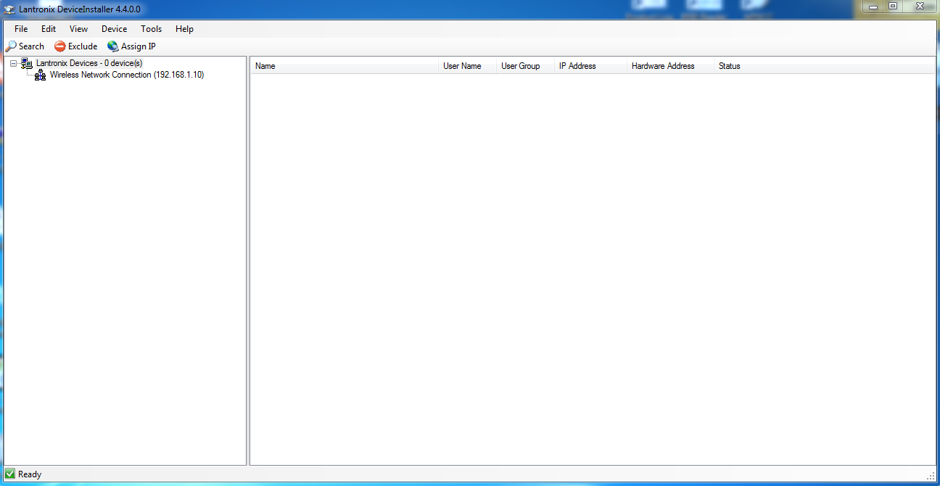
Once you launch the LAN Device Installer utility the search (discovery) for LAN-IP-485-TB Adapters will start automatically. If you change, connect, or disconnect any adapters then you can click the SEARCH button again at any time to update the list of adapters. In the right-hand list you should see your discovered LAN-IP-485-TB. From the right-hand list of discovered adapters select the one you need to configure. Select the ASSIGN IP button. Choose the option to assign a specific IP address and select NEXT. Complete the three boxes IP Address, Subnet Mask and Default Gateway. The latter is usually set at 0.0.0.0 as in itself an adapter is not required to find an internet connection. Knowledge of IP addressing, and subnet mask use is assumed, but you may need to consult the owner of the network for more information on allowable static addresses and correct subnet mask usage. Finally select the NEXT and the ASSIGN buttons. The LAN Device Installer utility will update you on the progress of the configuration and prompt you to select FINISH when complete. The list of discovered adapters will automatically update on completion. Continue to connect, discover, and configure any further LAN-IP-485-TB Adapters you have.
Remember, you will need to reference the new static IP address of the newly configured adapter segment, to the door or doors connected to it. Please see the Doors menu help topic on the Web Administration Console for more help and information on this and other door commissioning tips

Advanced LAN Setup
You should not normally need to configure any more information than detailed in the previous section. If you feel however, that you need to check all advance settings then you can enter the Web Configuration of any individual LAN Adapter then you can double click on the entry in the right-hand list and select the Web Configuration tab. Then select the green GO arrow button. On doing this a Windows Security dialogue box will appear prompting you to enter a Username and Password. Just select OK as there are no credentials set from the factory. The Line 1 Settings (serial settings) are usually set at the factory as follows:
RS232, 57600, 8, None, 1, None
If these are not correct, then you can select Serial Settings and make the necessary changes. Do not forget to choose Apply Changes to save all new settings. If you have altered settings and are unsure if you are correct, then you can reset (Apply Defaults) the adapter fully. You will then need to setup the Serial Settings as shown below.
Remember to select Apply Settings when making any changes!

LAN Adapter Serial Settings

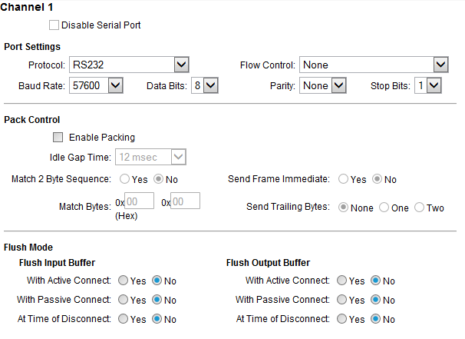

Installing System Doors in Remote Locations
It is possible to connect some or all your doors in a remote building or location and maintain them as one overall system. The doors are managed and communicated with over the world-wide-web using our LAN-IP-485-TB Adapters.

Router & Port Forwarding Considerations
You can connect multiple or single doors to be cable networked using a LAN-IP-485 Adapter plugged into a router or network switch in a remote location over the internet. You will need to know the fixed public IP address of the remote location and setup a port forward for port 10001 in that router to the LAN-IP-485-TB Adapter set unique static IP address. Please specify the IP address in the format e.g., WEB 92.168.177.234:1001 for the door definition in the software.

Multiple Adapters at Remote Locations
If you have multiple LAN-IP-485-TB Adapters in any one remote building or location, you can and must, provide unique port numbers for them (i.e., 10001, 10002, 10003 …). To change the port number for a single LAN-IP-485-TB Adapter you must use the LAN Adapter Installer utility as described earlier and reprogram the port numbers they listen on accordingly.

WebAdmin Server & Remote Management
Your single installation of the host software includes built-in capability for operating and managing your site installation remotely. You can manage your site from any PC inside and outside of your building, through any web browser or on portable devices such as tablets and smart phones.

Working Over the Internet
It is possible with the correct infrastructure, to open the ability to access the sites Web Administration Console from any external internet enabled device from anywhere in the world. To achieve this, the host computer that is actively running the software, must be connected to the internet and be able to accept incoming remote connections through an opened port of 4001. This is done by your router switch device that is connected to your ISP and setting up a port-forward for port 4001 to the host machines IP address. Remote users would then navigate remotely using your ISP generated IP address (external IP address) and the port number 4001. This can be a complicated topic and it is recommended that you contact Technical Support if you are unsure in anyway.

Starting the WebAdmin Server at Boot Time
To implement a reliable and permanently reachable remote connection, you may want to observe and implement the following modifications to the host computer running the software:
Windows Start-up Group - navigate to the Solo folder in the root of your HDD and find the application SoloServer.exe. Create a shortcut for this and add to your windows start-up group.
Internal IP Address - make sure that the main PC running the software has a fixed internal IP address, so it does not change when rebooted.
External IP Address - if you wish to connect to your installation from remote web browsers, ensure that you have a fixed external IP address from your ISP.
Create a Port Forward - you will also need to create a port forward for port number 4001 to the fixed IP address of the host computer running the software.

USB Desktop Enrolment Reader
The USB Desktop Reader simplifies the validation of our range of proximity cards & key-tags into your system. The simple presentation of a valid proximity card or tag will result in the unique ID number being paced in the relevant field when defining user records.

Installing
The USB Desktop Enrolment Reader can be connected to any Windows computer using the USB cable provided. No other connections or software installation is required.

Testing
To confirm correct operation, you can open any editor on your computer such as Notepad or Microsoft Word. Simply click on the editable page and present any proximity card or key-tag and you should see a 10-digit unique number appear on your screen. If this is the case, then the device is working correctly as an extension to your keyboard and wherever you normally type, this device can be used instead.

Secure Login
The USB Desktop Enrolment Reader also permits secure login to the Web Administration Console. This negates the need to enter a username and password, by simply presenting your ID card or key-tag at login.

Access Control System Schematics
The following schematics detail the possibilities for the Access Control System. With the use of our USB-485 and LAN-IP-485 Networking Adapters, you can create powerful door networks in the same or different geographical locations.

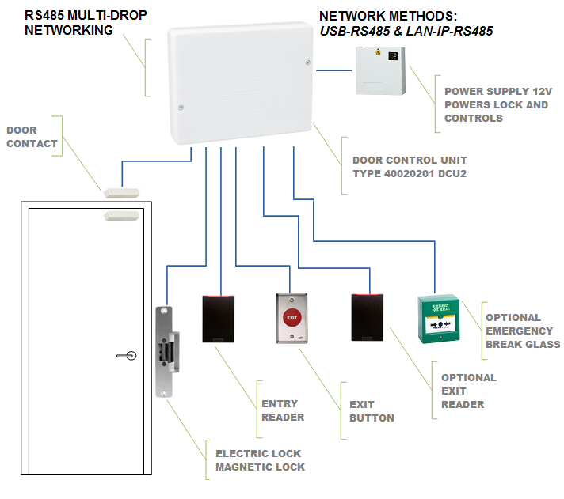

USB-485 Adapter Networking

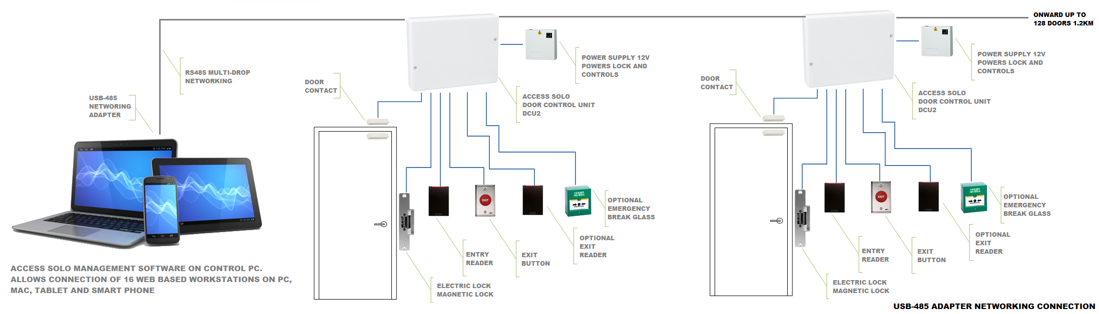
The above scheme represents a basic system connected to the host computer by a single USB-485 adapter. This lead can be extended to a maximum of 1200M and network up to 128 doors on a single system. You may only have one USB-485 Adapter on any single system. Please observe the correct cable types for the installation as detailed earlier in this manual.

USB-485 + LAN-IP-485 Adapter Networking

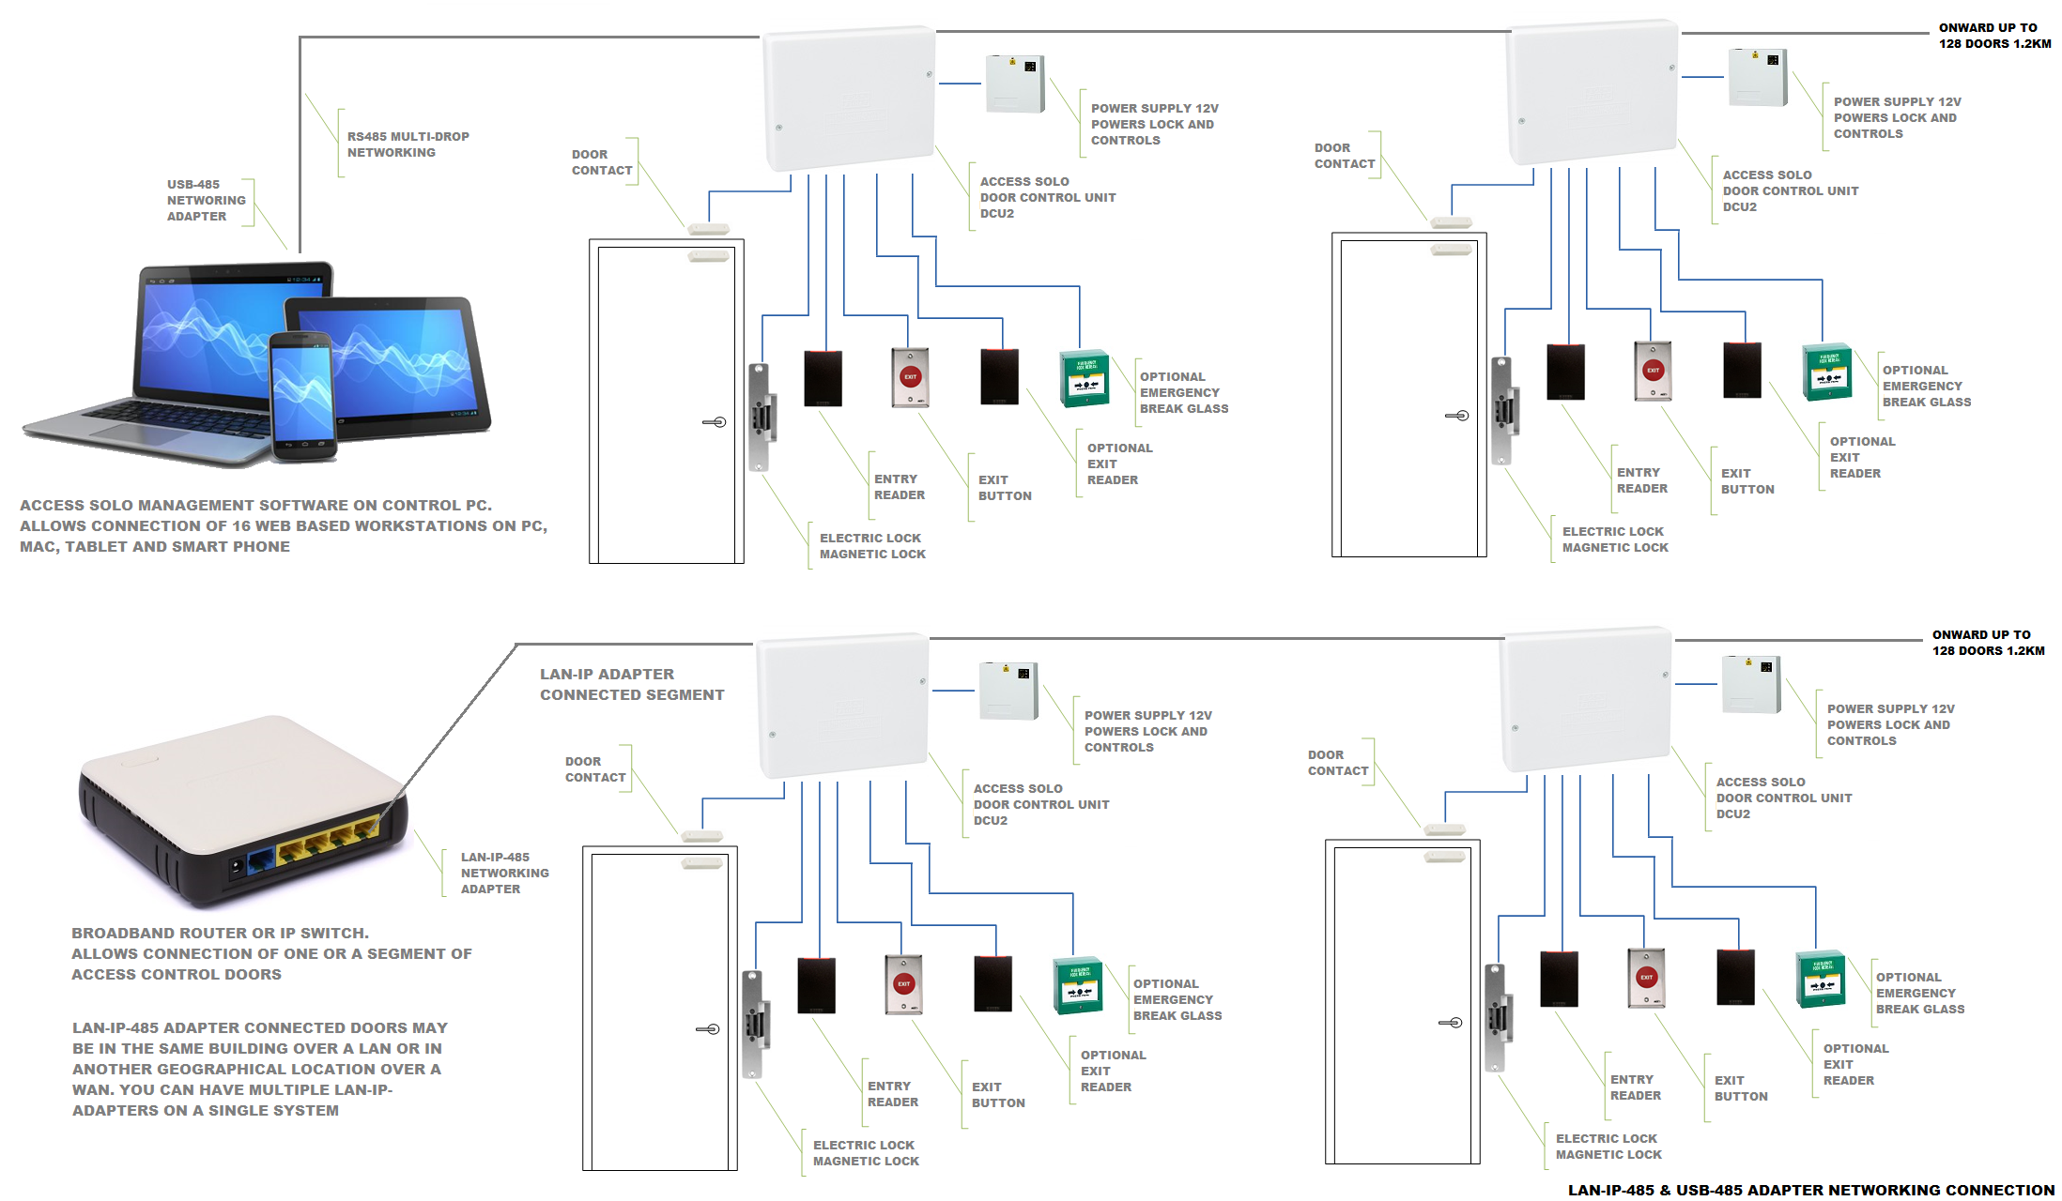
The above scheme represents a more advanced topography, including doors connected by a USB-485 adapter and further doors connected through LAN-IP connectivity by use of the LAN-IP-485 adapter. You may have as many LAN-IP-485 Adapters as you wish on your system, providing that the maximum number of 128 doors is not exceeded. Please observe the correct cable types for the installation as detailed earlier in this manual.
Please use the help menus available from the Web Administration Console to assist with the setup and day-to-day use of the access control system

Access Control Software
Once you have completed the installation of the access control hardware and you have tested each door as detailed in this manual, you can install the management software.

Download the WebAdmin Edition Software
To install the access control software, you will need to visit our website, if it was not provided by digital delivery. Please select and download the latest version of the access control software there.
The latest version will be called WebAdmin Edition Installer v5. xx or similar. Click on the link and you should be immediately directed to an area where you can download the compressed ZIP version. Make sure your ZIP download is sent to the computer that will have the software installed on it for simplicity and installation speed. Never install the software from a USB memory card, thumb drive or network location directly.

Installing the Software
Once you have downloaded the latest software in ZIP format to your computer you can right-click on it and select run. The ZIP will open and you can similarly run the .exe installer file. The installer will automatically install all utilities and desktop shortcuts. Once the installer has completed, it will prompt you to confirm the installation of some additional drivers and utilities you may need for your installation, so allow these.

Launching the Software
Once the installer has completed it is recommended that you reboot your computer. Once your computer has restarted you will observe two desktop shortcuts:
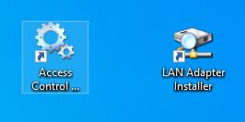
The LAN Adapter Installer shortcut is used at install to find and address our LAN-IP-485 adapters (not USB-485) for segments of access control units connected by this method. You can read more on how to do this in the section LAN-IP Device Installer Utility earlier.
The Access Control WebAdmin Start shortcut launches the background communications & web server from a single point. Double-click or right-click and select run from this icon to start the system. After a few moments you will notice the access control and web administration servers will launch with messages. Following this, you should see the default web browser automatically launch with the Web Administration Console running with the Login page ready.

Web Administration Console Login
To get started programming the system and gain access to the context help menus inside, you must first login to the system.
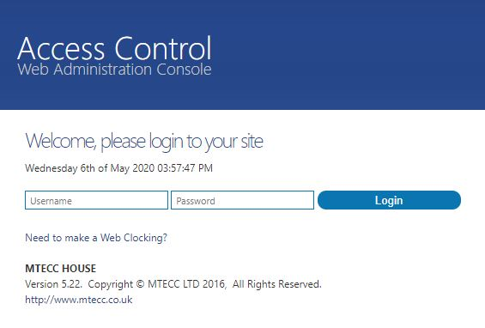
As this is a brand-new software installation you must use the default username and passwords of 'admin'. Once entered select the Login button. Once these credentials are accepted, the Events screen and main navigation menu will be displayed. If you have not defined any doors yet, you may be immediately redirected to the Doors screen.
At this point you are not limited to programming the system on this the host machine. As you have proved that the system is running you can now use any other computer, tablet or smart device that is connected to this computer. Simply launch the web browser on the new device and enter the local host computer IP address and port number e.g., 192.168.1.100:4001. To find the WebAdmin Server IP address for all connections, just look to the web browser window on the host machine in the address bar.

Help Resource
The Web Administration Console has an integrated help resource that can be viewed in full, from the Site | Help menu item. On each page you will see a '?' icon on the right-hand side of the screen, that is used to jump directly to the help topic in context with the page you are on. It is this resource that will take over, to guide you through the configuration and commissioning of all your access-controlled doors.

