REF. 1455 MEET MARINE DIGITAL PANEL
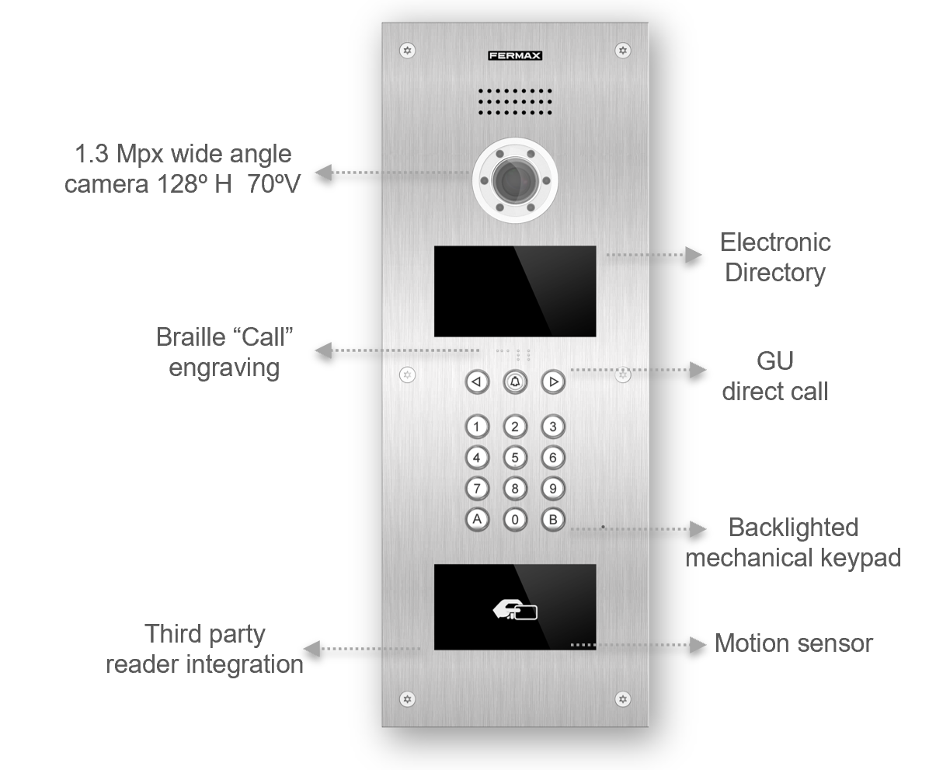

FEATURES
- 3mm 316L Stainless steel profile  - Backlighted metal keys and braille engraving  - IP54 weatherproof and IK09 resistance  - Hands Free Audio Communication  - 1.3 Mpx High Definition Colour Camera  - 4.3” Colour TFT Screen  - Electronic Directory  - Face recognition (up 6000 users)  - RTSP Camera Video Streaming | - Wiegand input/output for third party integration  - Access Control Integrated for 100.000 Cards  - Fire alarm with door unblocking and message to guard unit and MMS.  - Door forced and door left open alarms.  - Voice Synthesizer  - Available In 12 Languages  - Remote Firmware Update and Reset  - PoE Powered

REFERENCES
- Ref. 1455 MEET MARINE DIGITAL VIDEO PANEL
- Ref. 1456 MEET MARINE DIRECTORY PANEL
- Ref. 1457 MEET MARINE PANEL HOOD
- Ref. 1458 MEET MARINE SURFACE BOX
- Ref. 1459 MEET MARINE FLUSH BOX

FUNCTIONS
CALL TENANT  Visitors are able to call the desired tenant from the General Entry or the Block Entry.  ELECTRONIC DIRECTORY AND SEARCH  It is possible to store the name of the residents and select them in the electronic directory by scrolling with the arrow keys or selecting the character to search. | 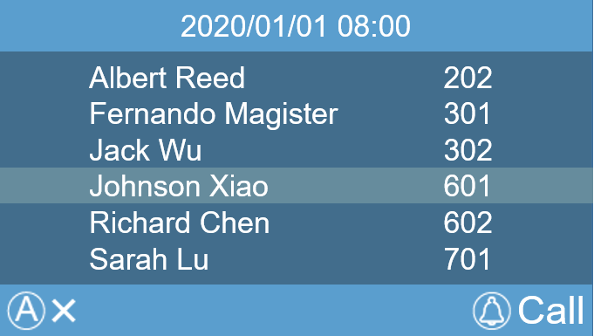  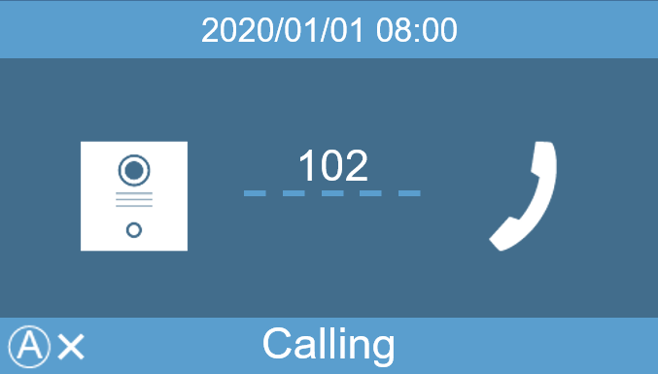
CALL TO GUARD UNIT  If the visitor or tenant needs to be assisted, they can call the main Guard Unit by entering pressing the “Bell Button” or dialing the number 9901. This call can be made from both General Entry and Block Entry.  Up to 98 different guard units can be called (9901...9998). | 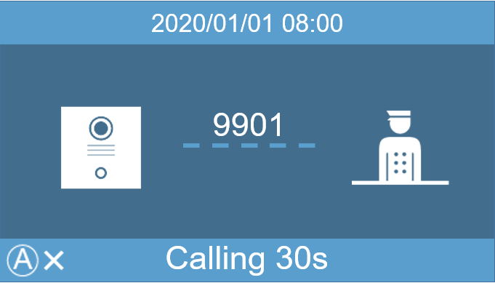
ACCESS PIN CODE  It is possible to define up to 8 access codes (pin) to open the door. Codes can have 4 to 6 digits long.  GUEST CODE  Using the GUEST CODE Module (ref.1494) it is possible to dial a code and be sent to a third party access control system that generates temporary codes for temporary visitors. | 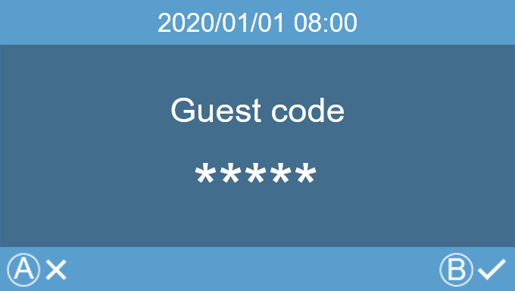  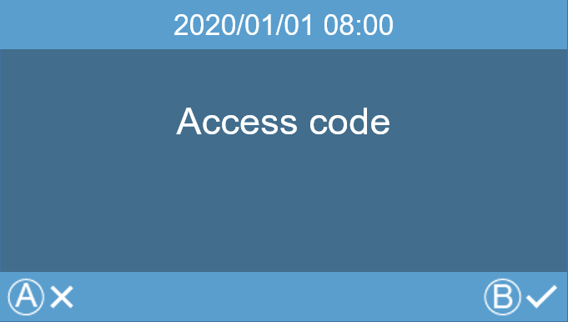
FACE RECOGNITION
Tenants can be identified in the front of the panel, and then the door been opened by means of pressing twice A key or selecting the function from the menu. Up to 6.000 users. .
PROXIMITY ACCESS CONTROL
The panel includes a Mifare card reader that controls up to 100.000 cards.
It is possible to manage cards by means of the MEET Management Software. In addition, the panel can be connected, to third party access control units through Wiegand 26 protocol.
IP CAMERAS
It is possible to configure up to 4 IP cameras that can be used as an auxiliary camera from all the monitors installed in the same block. These cameras can be used for tracking visitors through the corridors or common areas in the condominium.
ADDITIONAL RELAYS
It is possible to add up to 4 additional relays. (One Module Ref.1491 is required). Tenants can then open additional doors (garage, corridors, etc.), when called from any panel in their block or main entrance.
VIDEO STREAMING
RTSP video stream can be constantly sent to NVR or third-party system so that the panel camera can be used as a regular surveillance CCTV camera. Video stream and face recognition cannot work simultaneously.
TAMPER
The panel is protected against vandalism thanks to the tamper alarm switch, so in case the panel is removed from its flush box a warning message will be sent to concierge and/or MEET Management Software.
FIRE ALARM
Working with a fire detection system, when activated, an acoustic alarm is triggered in all the panels in the block.

TERMINALS

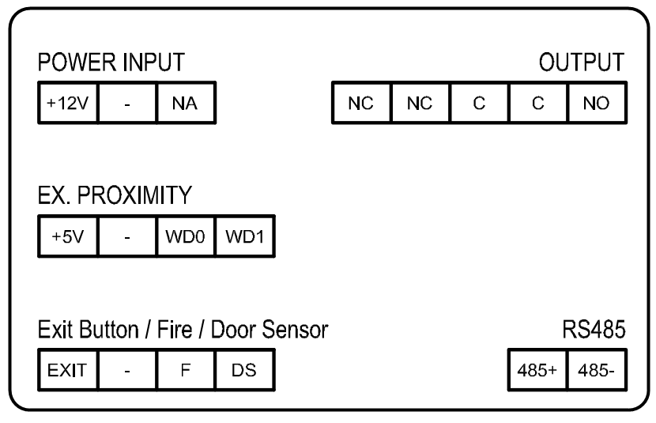 | - RJ-45: 10/100 Base -T Ethernet. PoE  - +12V, - : 12 Vdc power supply  - EXIT, -, F, DS Exit pushbutton, fire alarm and opened door sensor connections.  - +5V, - , WD0, WD1: 5 Vdc supply for external devices and Wiegand-26 protocol output or input  - NC, NC, C, C, NO: Relay output for electric lock terminals.  - 485+, 485-: RS-485 serial port for lift control & relays.

TECHNNICAL SPECIFICATIONS

System:  - CPU: Quad-core Cortex™-A7 1.5GHz  - GPU: Mali400MP2  - FLASH: 4GB  - SDRAM: 1GB DDR3L  Screen:  - 4.3” Color TFT  - Resolution 480 x 272 pixel  - View angle: 110º H, 90º V  - Contrast: 400/1  - Brightness: 200cd/m²  Audio Features:  - G.711 codec  - Audio OLR> 15dB  Camera:  - 1/3” CMOS Color  - Horizontal 128º, Vertical 70º  - 1.3 Mega Pixels  - Minimum Illumination 0.5 LUX. Automatic white led activation  - AWB | Power Consumption:  - On standby: 250 mA  - Working: 500 mA  - Heater enabled: additional 170mA  Working voltage:  - PoE  - 12 Vdc  Connectivity:  - Ethernet RJ-45 Connector  - RS485 connection port for lift control and aux relays module.  - Secondary access control reader connection (Wiegand 26)  - Built in web server for configuration and remote management  Working Environment:  - Temperature: -40 ºC to +70 ºC  - Humidity: 20 – 80% (Non-condensing)  - IP 54  - IK 09

DIMENSIONS

